Chapter 10, Problem 78.

Determine v_{o}(t) in the op amp circuit in Fig. 10.121 below.

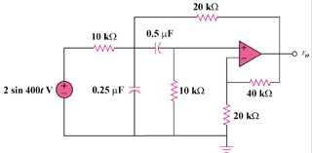

Figure 10.121
For Prob. 10.78.

